Friday, July 16, 2010 | Spitsbergen In Depth  R/V Akademik Ioffe

Storøya & Isispynten, Svalbard

06:00 | Early Bird coffee is served in the Lounge
07:00 | Wake-up call
07:30 | Breakfast is served in the Dining Room
09:00 | Excursion at Storøya  The name Storøya means “Great Island”, which was either a mistake or a sarcastic joke due to the islands modest size of only 40 sq km and its close position to the much larger Nordaustlandet, which lies just west of it. Storøya, like Kvitøya, have been closed off throughout the whole summer by dense drift ice until the late 20th Century, however, as we know, we still need luck to be able to land and even cruise these islands by Zodiac. Drift ice can easily block the shore, the waters are not well charted and bears are an inevitable threat. Storøya has approximately 5 sq km of ice-free land at the north tip of the island. It consists of low-lying rocky elevations and is an extensive series of raised beaches. This topography provides many depressions for wildlife to be hidden, thus great care will be taken whilst landing.
12:30  14:00 | Lunch is served in the Dining Room  Those in Port Side cabins, please join our ornithologist Sam in the Presentation Room for Seabird Survival Strategies
15:00 | Those in Starboard Side cabins, please join our ornithologist Sam in the Presentation Room for Seabird Survival Strategies
16:30 | Excursion at Isispynten  Isispynten is named after a river that runs through Oxford and was given by an expedition from there in 1935/36. Isispynten was once buried by the Austfonna ice cap of southeast Nordaustlandet, and until the 1990’s was a peninsula connected to the ice cap well itself. It is now a separate island, which can be circumnavigated in small boats. It has only a surface area of about 1 sq km, and its future is uncertain. It is possible, once the dead buried ice of the island has disappeared, that only sand, gravel and some boulders will be left. It is also possible that sea level rise will engulf the island, including it in the surrounding bathymetry. It is also possible that the Austfonna ice cap will advance, engulfing it once more as it had done for millennia before. The ice cliff at Austfonna is almost 200 kilometres long, making it the longest in the northern hemisphere.
TBA | The Gift Shop will be open
18:30 | Your Bartender, Diane, invites you to enjoy a cocktail during Happy Hour in the Bar (Deck 3)
19:30 | Dinner is served in the Dining Room
21:15 | Bar Talk Join Mikolaj in the Bar for Sex On The Beach
GENERAL INFORMATION:
Doctor: Mark Freedman - Cabin 538 - Phone 667 (Deck 5, starboard side, opposite the Clinic)
Reception: Phone 622 (Deck 3)
Hotel Office: the Hotel Office is located on Deck 3, Aft, towards the Bar
Radio Room: Phone 616 (Deck 6, adjacent to the Bridge)
Bridge: Phone 666 in case of emergency (Deck 6)
Gift shop opening times will be announced via the Public Announcement system

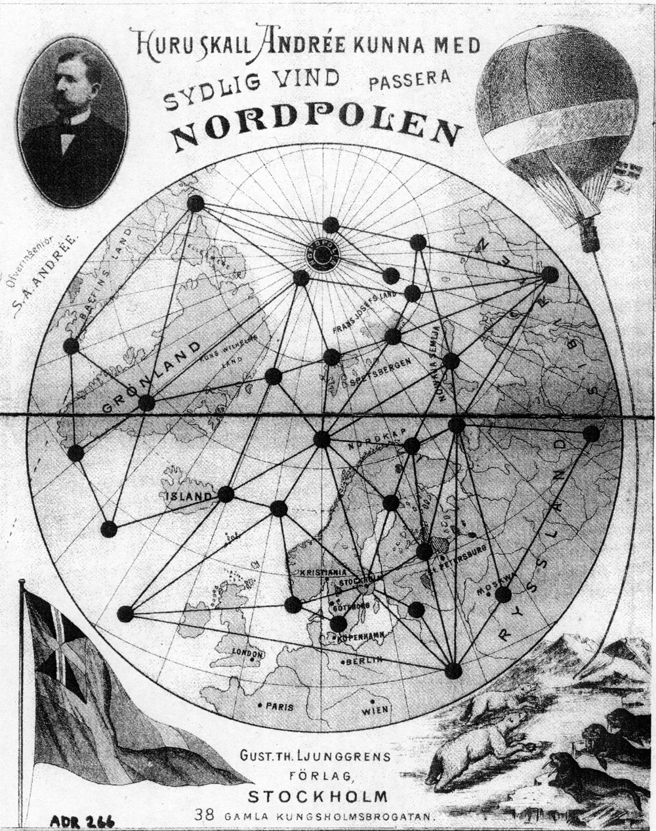

A poster advertising a board game featuring Andree’s expedition; just one example of the media buzz surrounding his expedition before it began.

